# KasrAlAiny Dermatology Department – Hair clinic

## User interface flow pages:

### Search existing page:

Upon initializing the app, the user is prompted for a search criterion to check if this patient exists. Criteria are :

1. Patient Name (can’t be used alone, must add another criterion from below)
2. Patient Phone number
3. Patient Hospital number
4. Social ID

If any of the fields returned an existing patient, the user is redirected to “View existing page”

Else : redirected to “Create New Patient” page

### Create New Patient C:\Users\Hatem II\AppData\Local\Microsoft\Windows\INetCache\Content.Word\37188685_10155907887193742_3348348266214326272_n.jpg

A form page as above , feeds into the following tables :

* Patients
* Investigations
* Treatments
* Hair loss sheet

Then prompts for an extra specific sheet, that correspondingly feeds into

* Alopecia Areata
* Androgenic Alopecia  
    
  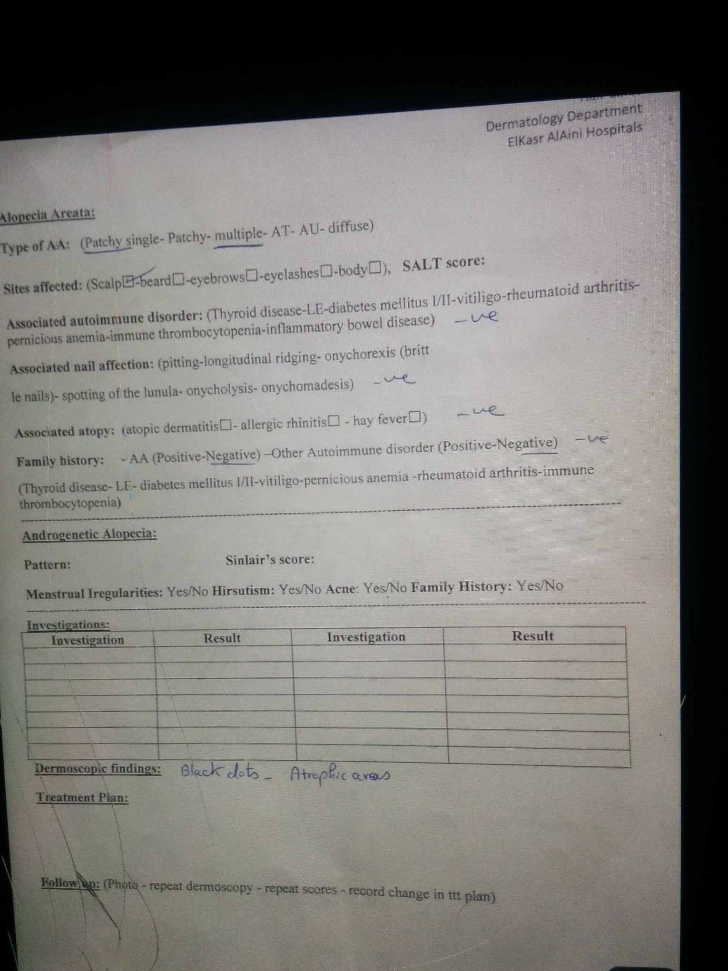

Finally there is a save button that inserts the new patient and redirects user to “View existing patient” page with the newly entered patient on focus

### View existing patient

A page that contains 4 divisions:

* Patient data : A form-like (without input fields) representation of the patient’ data , reading from tables : [Patients, Hair loss sheet] **with an EDIT button**
* Investigations: looks like an excel worksheet or a log. Reads from [Investigations] **with an ADD button**
* Treatments: looks like an excel worksheet or a log. Reads from [Treatments] **with an ADD button**
* Examination & Follow up: looks like an excel worksheet or a log. Reads from [Examination & Follow up] **with an ADD button**

Upon managing the patient in anyway , the user should ADD or EDIT those divisions